Operations/Work/Job Activity covered by this assessment: Macro Hardness Tester (Rockwell)
Required Personal Protective Equipment (PPE) :

Safety glasses must be worn at times. |   Long and loose hair must be contained.
  Appropriate footwear with substantial uppers must be worn. |   Close fitting/protective clothing to cover arms and legs must be worn.
Respiratory protection devices required. |   Oil free leather gloves and spats must be worn.

Hearing protection must be used when using this machine.

- Identify the hardness scale required for the sample under testing.(HRA,HRB,HRC,HR15N & HR15Y)(A)Fig.1
- Turn the knob to Rockwell position for scales HRA,HRB & HRC and Superficial position for scales HR15N & HR15Y (B) (Fig.2 a,b)
- Select the load based on the selected scale by rotating the knob.(C) (Table 1)
- Mount the suitable indentor based on selected scale.(D)Refer table 1.
- Clean the test-block with tissue paper and place it on the special anvil or work table of the machine.(E)
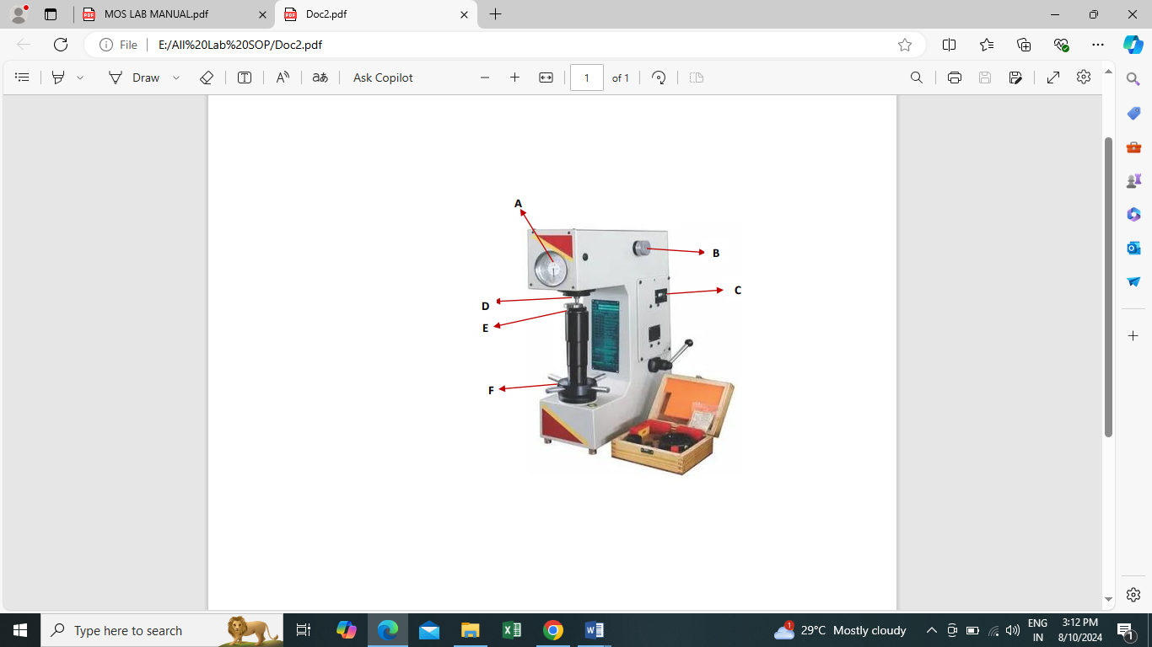
- Ensure the loading lever is pulled forward as shown in fig (Fig.3)
- Rotate the capston wheel slowly to raise the test specimen till it comes in contact with the indentor tip.(F)
- Ensure the corresponding scale is set at zero.(A)
- Push back the loading lever as shown in fig.(Fig.4)
- After time lapse of 5 seconds record the reading shown on the scale.
- Repeat the steps shown in Sr.no 5 to 8 three times and record the readings.
- From the readings obtained from sr.no 11, record the deviation from the standard value.
- Now the specimen is kept on the anvil and steps 5 to 8 are repeated.
- After recording the values, pull forward the loading lever to the unloading position.(Fig.3)

(Fig.2 a) (Fig.2 b)
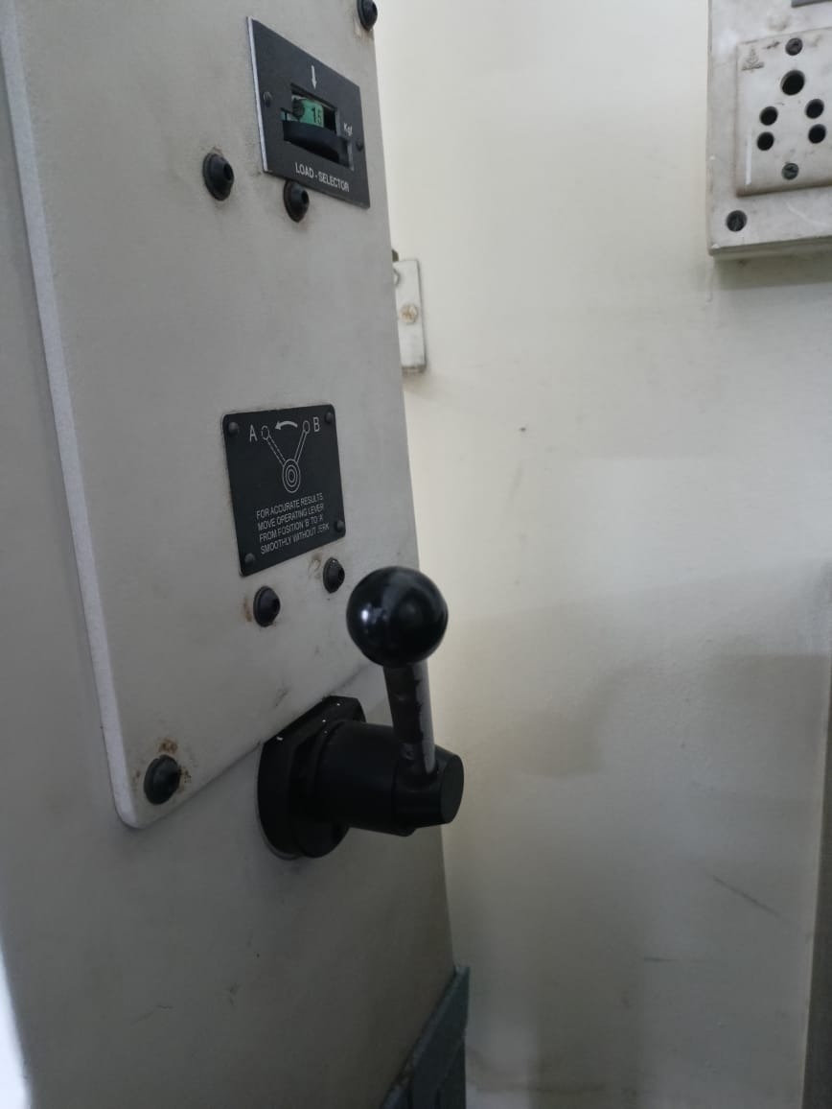

SCALE | LOAD | INDENTOR | DIAL SCALE
HRA | 60 Kg | DIAMOND | BLACK
HRB | 100 Kg | 1/16” BALL | RED
HRC | 150 Kg | DIAMOND | BLACK
HR15Y | 15 Kg | ½” BALL | N/T
HR15N | 15 Kg | DIAMOND | N/T

(Fig.3) (Fig.4)
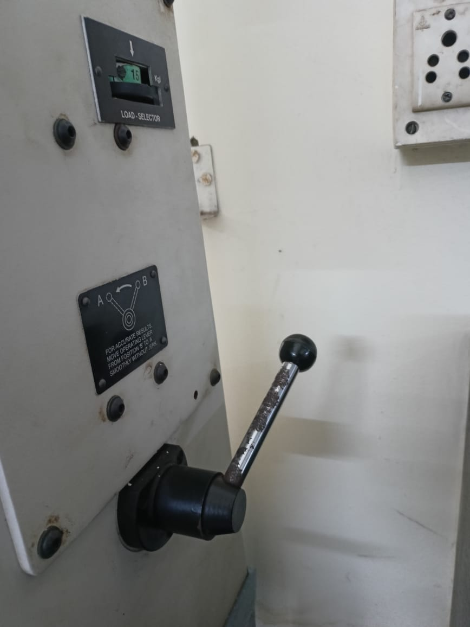
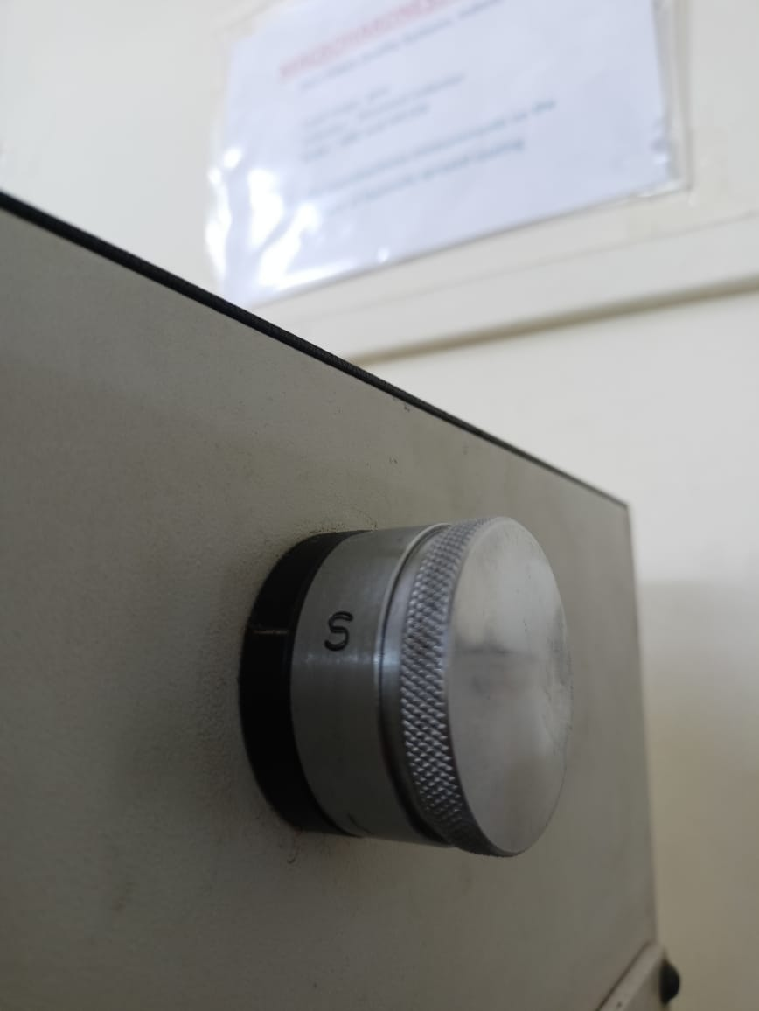
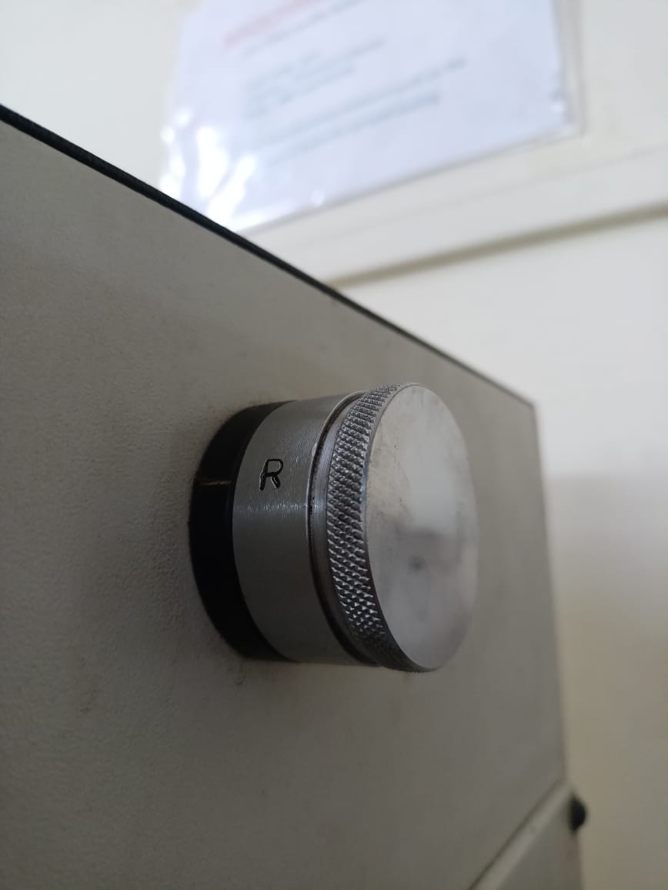
(Table.1)

